
GLH Business Proposal
[Document subtitle]

Contents
Business Context 1

Business Context
Provide information about the producers, their methods and benefits of buying locally
The client has asked me to provide information about the producers, their methods and benefits of buying locally in the digital solution. In these modern times people want to know where their food is coming from ,how it was produced ,who it was produced by and how it impacts the environment .Adding this feature will lead to customer retention as customers will feel confident about making purchases from our client as they feel that they have enough information to make this decision . This may also puts our client above their competition as there many companies that disregard this section in their digital solution .Without this section customers would be worried about , misleading labels ,untrustworthy producers and pesticides . Adding the benefits of buying locally such as environmental benefits and community benefits like spending money within a local area can help convince customers to spend their money on money on their local farms and food producers rather than going to mainstream sources .Overall, this would also lead to the economic growth and of all the local farms and food producers within GLH .

View products with transparent pricing and availability
The client has asked me to create a digital platform that will allow customers to view products with transparent pricing and availability . Many people nowadays use mobile devices so by having this digital platform allows our client to showcase their services and products to a wider audience .Another issue being solved here is the confusion customers tend to get when it comes to pricing .So by having transparent pricing customers will constantly know If any changes have occurred when it comes to pricing and they will also know the details for the prices . Another problem with the traditional methods our client has been using up until now is the issue of uncertain availability of on products . Customers don’t have a concrete way of knowing if certain items are in stock or not .So by having the digital showcase real time stock of products it reduces the chances of wasted transactions which leads to customer satisfaction. Overall, this would reduce the amount of time members of staff spend answering questions leading to better workflow.
Place orders for collection or delivery
The client has asked me to add a feature that allows customers to place orders for collection and delivery .The problem being solved here is that it allows customers to purchase products remotely which is important as some customers may be too busy or physically unable to head to the our clients shop . Another issue being solved is long queues that tend to occur when too many customers come into the shop which leads to greater customer satisfaction .This feature would also reduce the stress on staff as they can focus on preparing the customer’s order confidently knowing how the customer wants to receive their order .
Manage their accounts and view order history
Allowing customers to manage their accounts on this digital solution will solve the issue of re-entering details .As users will be able to store and update all of their data account data in this area , which includes their names, email address payment details and so on .Allowing customers to view their order history provides them with the information on all of their previous orders the customer can also use these as a reference for when issues occur with their orders .They can use order numbers time and items to refer to when they contact support. Overall this feature will allow our clients customer to have a more personalised experience when using this digital solution.
Provide a dashboard to enable producers to manage stock levels, update product details and view orders
Adding this feature would enhance the workflow of producers whilst reducing the stress they face when it comes to managing this areas using traditional methods . Producers would be able to manage stock levels at a greater speed which ensures that customers and always have accurate data on stock levels leading to a decrease in stock related issues such incorrect and inconsistent numbers .Consistency on the digital solution leads to overall customer satisfaction .Another point is that it minimises chances of paused workflow because items run out unexpectedly due to inaccurate and outdated stock figures . Product details can also be updated at the same rate as stock levels which leads to a consistent information output across the digital solution as a whole . Lastly, viewing orders allows problems like misplaced orders and incorrect details to be identified and dealt with within a short space of time . This means that our client’s workflow won’t be interrupted by issues like these, as they won’t have to spend as much time identifying and coming up with solutions to these problems , as they tend to slowdown workflow leading to less revenue being made .
Order management, scheduling and tracking features
The client has suggesting adding order management, scheduling and tracking features to the digital solution .Adding this features would greatly enhance the experiences of our customers when they use the digital solution . Firstly , with an order management system customers can see the status of their orders through confirmations, full breakdowns collection and delivery details . They can also make changes to the their delivery details or they can even make cancellations and refunds to through this feature from their account without having to go through long and impractical methods such as calls and messages. Scheduling features will allow customers to know exactly when to expect their deliveries or when to collect their as they will be shown certain time frames and dates which reduces complaints form late deliveries or unfinished order processing during the time of collection .Lastly, tracking features allows customers to get real time updates on their orders this improves the customers awareness on their status of their order which decreases the chances of customers missing their deliveries or not turning up to collect their orders which regularly occurs in traditional methods.
A loyalty scheme that provides discounts and special offers
Loyalty schemes are one of the most popular methods used in this industry to the increase customer retention .Offering discounts and special offers rewards loyal customers which are important in the long term for our client whilst also increasing overall sales .This solves weak retention as customers will now have an incentive to continue making purchases from our client .
Accessibility features to support a wide range of users
Accessibility features ensure that the digital solution can be used by customers with various types of conditions which is beneficial to our client as they will contribute to overall customer satisfaction .This will also broaden the types of customers our client serves .

Project Aim
- The digital solution should allow customers to :
- View products with transparent pricing and availability
- Place orders for collection or delivery
- Manage their accounts and view order history
- Provide a dashboard to enable producers to manage stock levels, update product details and view orders
- Order management, scheduling and tracking features
- A loyalty scheme that provides discounts and special offers
- Accessibility features to support a wide range of users

Functional Requirements and User Acceptance Criteria
Customer – Henry has found out about GLC’s services but has been unable to travel to their shop because he recently had a leg injury . But he really wants to their products .
Customer – Aisha tends to collect her order late as she can’t keep a track on when her order is ready to be collected
Producer- Adam, struggles to keep his stock figures and upto date when there a lot of orders as he usually relies on pen and paper

Functional Requirement | User Story | User Acceptance Criteria | Justification
As a …
I want to…
So that…
Log In | As a returning user I want to log in so that I can view products place orders and manage my account check order history | - User enters homepage  - User clicks on person icon from navbar  - User enters their email in the blank field  - User enters the password they used when registering  - User clicks sign in  - User is logged in  - Incorrect log ins should trigger clear error message  - System must logout users after inactivity | Frequent customers will need to log back into their own using the email and password they used during the registration. Once they are logged in they can access features that aren’t available when logged out. It also adds protection from unauthorised access.
Register | As a new customer I should be able to  register an account so that I can manage my bookings and data . | Click on register icon  Enter Email  Enter Password  Re-Enter Password  Click Register | This is needed because customer accounts were one of the features my clients wants to be available in the digital solution. So if new customers come across this digital solution they would need to register to get an account. This also adds security as their data will only linked to their own account.
Home Page | As a new user I should be able to access the home page so that I have an idea on what Greenfield Local Hub do and what they have to offer . | - User clicks on digital solution link  - User reads the content on the homepage | This is needed because the homepage will display brief information about the business. It also has to be the landing page for a user.
Privacy Policy Page | All customers need to be able to access the privacy policy page so that their collected data is being used for. | - User enters homepage  - User clicks on privacy from navbar  - User reads the information on the website | This will be done because it is one of the mandatory points for the task brief .  The digital solution will collect customer data and businesses are legally required to explain how the data is used, stored and protected. Production policies and staff details will available on this page .
Order Page | As a user I should be able to make an order containing all the items I want to purchase | - User Logs In to their account  - User clicks on a product  - User toggles the quantity of the product  - User clicks on add to bag  - User clicks on basket  - User clicks on proceed to check out  - User enters card details on blank spaces  - User chooses delivery or collection  - User clicks pay now | This will allow the user to purchase their orders and from the digital solution.  In this page they will be entering their payment details so for safety reasons ordering will only possible when the user is logged in.

Non-Functional Requirements
Performance
Non-Functional Requirement | Justification | KPI
The system should be able to load each page effectively | Faster performance is needed to not annoy the user. This is so that the user will be satisfied with the interaction with website making them more likely to visit again. | Pages should be loading in under 1 second
Security
Non-Functional Requirement | Justification | KPI
Scalability
Non-Functional Requirement | Justification | KPI
Capacity
Non-Functional Requirement | Justification | KPI
Reliability
Non-Functional Requirement | Justification | KPI
Usability
Non-Functional Requirement | Justification | KPI
Accessibility
Non-Functional Requirement | Justification | KPI

Hierarchy Diagram
- Draw a diagram showing the order in which the functional requirements must be completed.
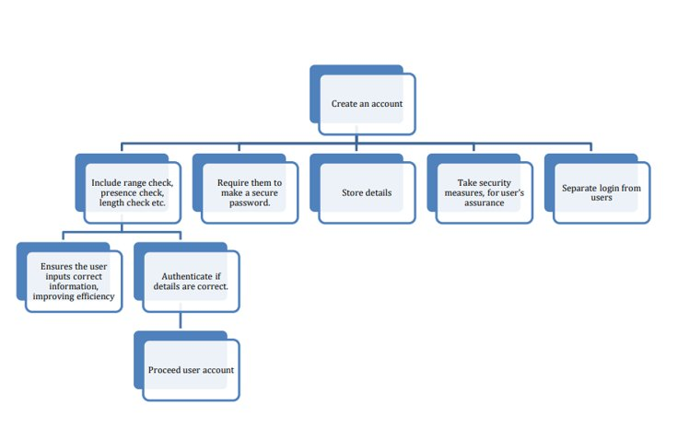

UI Consideration
- Briefly discuss the considerations that you will have to think about when making the user interface thinking about the target audience.
- Talk about colours, images, layout, text, content and more.
Security Considerations
- What security risks will be involved in creating your web-based solution?
- How will you mitigate these potential risks?
- Make sure each one is specific to your particular solution and is not just generic
Legal and Regulatory Guideline Considerations
- What legal guidelines must you consider when creating the web-based solution?
- Be specific about both computing legislation but also industry related legislation that you must follow

